Approved by the order of the Chairman of "Azerbaijan Caspian Shipping Closed Joint Stock Company dated 1st of December 2016 No. 216.

AZERBAIJAN CASPIAN SHIPPING CLOSED JOINT STOCK COMPANY IS ANNOUNCING OPEN BIDDING ON THE PROCUREMENT OF SERVICES RELATED TO THE INSTALLATION OF BATHROOM EQUIPMENT (INCLUSIVE OF MATERIALS AND WORKMANSHIP) IN THE HIGH RISE RESIDENTIAL BUILDING ON THE BALANCE SHEET OF DENIZCHI HOUSING CONSTRUCTION COOPERATIVE
B I D D I N G No. AM145/2022

Submission documentation required for participation in the bidding:
- Application for participation in the bidding (template has been attached hereto);
- Bank evidence as a proof of participation fee;
- Bidding offer:
- Bank document confirming financial condition of the consignor within the last year (or within the period of operation if less than one year);
- Statement issued by the relevant tax authorities on the absence of expired commitments associated with taxes and other compulsory payments and failure of obligations set forth in the Tax Code of the Republic of Azerbaijan for the last one year (excluding the period of suspension).

At the initial stage, application for participation in the bidding ( signed and stamped ) and bank evidence proving payment of participation fee (excluding bidding offer) shall be submitted in English, Russian or in Azerbaijani to the official address of Azerbaijan Caspian Shipping CJSC (hereinafter referred to as "ASCO" or "Procuring Organization") through email address of contact person in charge by 17.00 (Baku time) on 19th of August 2022. Whereas, other necessary documents shall be submitted as enclosed in the bidding offer envelope.

Description (list) of goods, works or services has been attached hereto.

The participation fee and Collection of General Terms and Conditions:
- Any participant (bidder), who desires to participate in the bidding, shall pay for participation fee stated below (the payment order shall necessarily state the name of the organization holding open bidding and the subject of the bidding) and shall submit the evidence as a proof of payment to ASCO not later than the date stipulated in section one. All participants (bidders), who have fulfilled these requirements, may obtain General Terms and Conditions relating to the procurement subject from contact person in charge by the date envisaged in section IV of this announcement at any time from 08.00 till 17.00 in any business day of the week.

- Participation fee amount (VAT exclusive): AZN 250

- The participation fee may be paid in AZN or equivalent amount thereof in USD or EURO.
- Account No.:
AZN | USD | EURO
Name: The International Bank of Azerbaijan  ABB- Customer Service Department  Code: 805250  TAX ID: 9900001881  Correspondent account: AZ03NABZ01350100000000002944  SWIFT: IBAZAZ2X  Beneficiary: AZARB.XAZAR DANIZ GAMICILIYI QSC  TAX ID: 1701579951  Account No. (AZN): AZ36IBAZ38050019441115341120 | Intermediary Bank: Citibank N.Y,  New York  Acc.36083186, SWIFT: CITIUS33  Beneficiary Bank: The International Bank of Azerbaijan  IBA- Customer Service Department  SWIFT: IBAZAZ2X  Nizami str., 67  Beneficiary: AZARB.XAZAR DANIZ GAMICILIYI QSC  TAX ID: 1701579951  Account No.: AZ26IBAZ38150018401115341120 | Intermediary Bank: Commerzbank AG, Frankfurt am Main  SWIFT: COBADEFF  ACC # 400 88 660 3001  Beneficiary Bank: The International Bank of Azerbaijan,  IBA-Premier Customer Service  SWIFT: IBAZAZ2X  Nizami str., 67  Beneficiary: Azerbaijan Caspian Shipping CJSC  TAX ID: 1701579951  Account No.: AZ06IBAZ38150019781115341120

- Except for circumstances where the bidding is cancelled by ASCO, participation fee shall in no case be refunded!

Security for a bidding offer:
- The bank guarantee is required in the amount of at least 1 (one) % of the bidding offer price. A bank guarantee sample shall be specified in the General Terms and Conditions.
- Bank guarantees shall be submitted as enclosed in the bidding offer envelope along with the bidding offer. Otherwise, the Purchasing Organization shall reserve the right to reject such offer.
- The financial institution that issued the guarantee should be acknowledged in the Republic of Azerbaijan and / or international financial transactions. The purchasing organization shall reserve the right not to accept and reject any unreliable bank guarantee.
- Persons wishing to participate in the bidding and intending to submit another type of warranty (letter of credit, securities, transfer of funds to the special banking account set forth by the Procuring Organization in the bidding documents, deposit and other financial assets) shall request and obtain a consent from ASCO through the contact person reflected in the announcement on the acceptability of such type of warranty.
- A contract performance bond is required in the amount of 3 (three) % of the purchase price.
- For the current procurement operation, the Procuring Organization is expected to make payment only after the goods have been delivered to the warehouse, no advance payment has been intended.
Contract Performance Term:

Final deadline date and time for submission of the bidding offer:
- All participants, which have submitted their application for participation in the bidding and bank evidence as a proof of payment of participation fee by the date and time stipulated in section one, and shall submit their bidding offer (one original and two copies) enclosed in sealed envelope to ASCO by 17.00 Baku time on August 24, 2022.

- All bidding offer envelopes submitted after the above-mentioned date and time shall be returned unopened.

Address of the procuring company:
The Azerbaijan Republic, Baku city, AZ1003 (postcode), 2 Mikayil Useynov street, Procurement Committee of ASCO.
Contact person in charge:
Rahim Abbasov
Senior procurement specialist at the Procurement Department of ASCO
Telephone No.: +99450 2740277
Email address: rahim.abbasov@asco.az, tender@asco.az

Contact person on legal issues:
Landline No.: +994 12 4043700 (ext:1262)
Email address: tender@asco.az
Date and time assigned for the opening of bidding offer envelopes:
Opening of the envelopes shall take place on August 25, 2022 at 12.00 Baku time in the address set forth in section V of the announcement.
Persons wishing to participate in the opening of the envelopes shall submit a document confirming their permission to participate (the relevant power of attorney from the participating legal entity or natural person) and the ID card at least half an hour before the commencement of the bidding.
Information on the winner of the bidding :
Information on the winner of the bidding will be posted in the "Announcements" section of the ASCO official website.

Other conditions of the bidding :
Technical requirements of work related to the installation of bathroom equipment in the high rise residential buildings with a kindergarten on the ground floor on the balance sheet of the Denizchi Construction Housing Cooperative under "ACS" CJSC:
- The requirements of the Project documentation shall be followed when installing bathroom equipment.
- Quality and conformity certificates shall be provided for all used materials.
- Delivery time for the works shall be specified.
- A license (for the construction of utilities and networks) shall be submitted for construction works.
- A bidder engaged in construction works shall have officially registered employees and contract (copy of the contract) concluded with them.
- A bidder shall submit work experience (contracts) on the subject of bidding.
- While performing construction works, safety rules of ACS CJSC and construction safety rules shall be complied with.

(On the participant`s letter head)
APPLICATION FOR PARTICIPATION IN
THE OPEN BIDDING

___________ city “__”_______20_
___________№

To the attention of the Chairman of ASCO Procurement Committee
Mr Jabrail Mahmudlu

We, hereby confirm the intention of [ to state full name of the participant ] to participate in the open bidding No. [ bidding No. shall be inserted by participant ] announced by ASCO in respect of procurement of "__________________" .
Moreover, we confirm that no winding - up or bankruptcy proceeding is being performed or there is no circumstance of cessation of activities or any other circumstance that may impede participation of [ to state full name of the participant ] in the stated bidding.
In addition, we warrant that [ to state full name of the participant ] is not an affiliate of ASCO.
Below-mentioned contact details are available to respond to any question that may emerge in relation to the documents submitted and other issues:

- Contact person in charge:
- Position of the contact person:
- Telephone No.:
- E-mail:

Attachment:
- Original of the bank evidence as a proof of payment of participation fee – __ page(s).

________________________________ _______________________
(initials of the authorized person) (signature of the authorized person)
_________________________________
(position of the authorized person)

STAMP HERE

LIST OF THE GOODS:

Item no. | Nomination of goods and services | View | Measurement unit | Quantity
1 | Installation of pedestal washbasin set (Pedestal (60 x 45 cm) (inclusive of materials) | 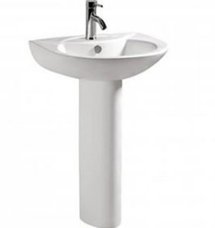 | pcs | 502
2 | Installation of pedestal washbasin set (Pedestal (51 x 33 cm) (inclusive of materials) | 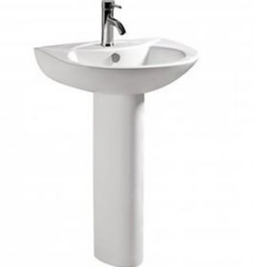 | pcs | 409
3 | Installation of U-bend pipe for pedestal washbasin 85 cm (material not included) |  | pcs | 911
4 | Installation of water mixer (chrome) 17 x 13 cm (inclusive of materials) | 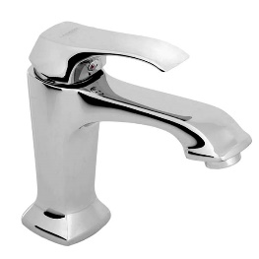 | pcs | 911
5 | Installation of connection pipe for water mixer (60 cm) (set consists of 2 units) (inclusive of materials) | 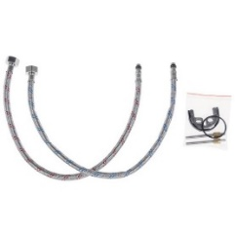 | set | 1822
6 | Installation of Arco type faucet (outlet 15 mm) 10 x 5 cm (inclusive of materials) | 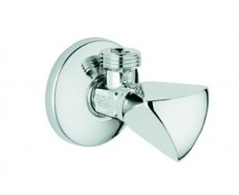 | pcs | 3389
7 | Installation of Arco type tap (outlet 20 mm, washing machine, dish washing machine) 10 x 5 cm (inclusive of materials) |  | pcs | 852
8 | Installation of mirror (50 x 70 cm) (inclusive of materials) | 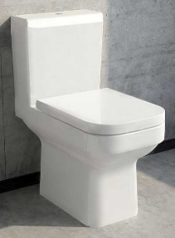  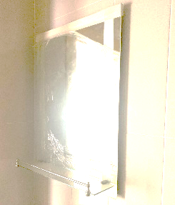 | pcs | 911
9 | Installation of European type toilet bowl (including water tank and lid) 68 x 37 x 75 cm (inclusive of materials) |  | pcs | 654
10 | Installation of U-bend for the toilet bowl  43 cm (inclusive of materials) |  | pcs | 654
11 | Installation of pipe connecting to arco tap and toilet water tank (60 cm) (inclusive of materials) | 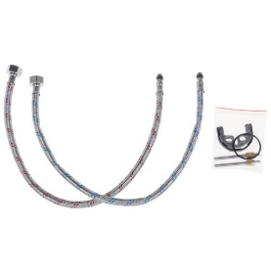 | pcs | 654
12 | Installation of hygienic hand held bidet shower (complete with water mixer, chrome) 18 x 9 x 13 cm (inclusive of materials) | 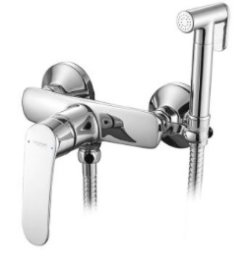 | set | 654
13 | Installation of 6 mm tempered glass partition (frozen glass, single direction, stainless steel profile)  1,8 x 1,90 - 302 pcs, 1,7 x 1,90 - 152 pcs, 2,2 x 1,90 - 32 pcs, 1,9 x 1,90 - 16 pcs |  | m2 | 1715.32
14 | Installation of U-bend for a kitchen washbasin 85 cm (inclusive of materials) |  | pcs | 487
15 | Installation of a shower tap set (including water mixer, faucet, hand held shower, top shower, chromium) 105 x 33 cm (inclusive of materials) | 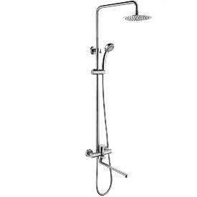 | set | 502
16 | Installation of water mixer for kitchen 30 x 25 cm (inclusive of materials) | 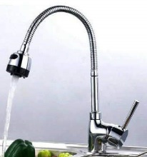 | pcs | 487

For technical questions please contact :
Engineer of the Construction and Repair Division
Tel: +994502740251
E-mail: cavid.eminov@asco.az

Payment condition is accepted only on actual basis and other type offers will be rejected.

Due diligence shall be performed in accordance with the Procurement Guidelines of ASCO prior to the conclusion of the purchase agreement with the winner of the bidding.
The company shall enter through this link http: //asco.az/sirket/satinalmalar/podratcilarin-elektron-muraciet-formasi// to complete the special form or submit the following documents:
- Articles of Association of the company (all amendments and changes including)
- An extract from state registry of commercial legal entities (such extract to be issued not later than last 1 month)
- Information on the founder in case if the founder of the company is a legal entity
- Certificate of Tax Payer`s Identification Number
- Audited accounting balance sheet or tax declaration (depending on the taxation system) / reference issued by taxation bodies on non-existence of debts for tax
- Identification card of the legal representative
- Licenses necessary for provision of the relevant services / works (if any)
No agreement of purchase shall be concluded with the company which did not present the above-mentioned documents or failed to be assessed positively as a result of the due diligence performed and shall be excluded from the bidding!

