Approved by the order of the Chairman of "Azerbaijan Caspian Shipping Closed Joint Stock Company dated 1st of December 2016 No. 216.

AZERBAIJAN CASPIAN SHIPPING CLOSED JOINT STOCK COMPANY IS ANNOUNCING OPEN BIDDING FOR THE PROCUREMENT OF MDF DOORS AND FLOOR SKIRTING REUIRED FOR ADMINISTRATIVE BUILDING OF THE MARINE TRANSPORTATION FLEET:
B I D D I N G No. AM069 / 2024

Submission documentation required for participation in the bidding :
- Application for participation in the bidding (template has been attached hereto) ;
- Bank evidence as a proof of participation fee ;
- Bidding offer :
- Bank document confirming financial condition of the consignor within the last year (or within the period of operation if less than one year) ;
- Statement issued by the relevant tax authorities on the absence of expired commitments associated with taxes and other compulsory payments and failure of obligations set forth in the Tax Code of the Republic of Azerbaijan for the last one year (excluding the period of suspension).

At the initial stage, application for participation in the bidding ( signed and stamped ) and bank evidence proving payment of participation fee (excluding bidding offer) shall be submitted in English, Russian or in Azerbaijani to the official address of Azerbaijan Caspian Shipping CJSC (hereinafter referred to as "ASCO" or "Procuring Organization") through email address of contact person in charge by 17.00 (Baku time) on may 25, 2024. Whereas, other necessary documents shall be submitted as enclosed in the bidding offer envelope.

Description (list) of goods, works or services has been attached hereto.

The participation fee and Collection of General Terms and Conditions:
- Any participant (bidder), who desires to participate in the bidding, shall pay for participation fee stated below (the payment order shall necessarily state the name of the organization holding open bidding and the subject of the bidding) and shall submit the evidence as a proof of payment to ASCO not later than the date stipulated in section one. All participants (bidders), who have fulfilled these requirements, may obtain General Terms and Conditions relating to the procurement subject from contact person in charge by the date envisaged in section IV of this announcement at any time from 09.00 till 18.00 in any business day of a week.

- Participation fee amount (VAT exclusive): 100 Azn.

- The participation fee may be paid in AZN or equivalent amount thereof in USD or EURO.
- Account No. :
AZN | USD | EURO
Name : The International Bank of Azerbaijan  ABB- Customer Service Department  Code : 805250  TAX ID : 9900001881  Correspondent account : AZ03NABZ01350100000000002944  SWIFT : IBAZAZ2X  Beneficiary: AZARB.XAZAR DANIZ GAMICILIYI QSC  TAX ID : 1701579951  Account No. (AZN) : AZ36IBAZ38050019441115341120 | Intermediary Bank : Citibank N.Y,  New York  Acc.36083186, SWIFT: CITIUS33  Beneficiary Bank : The International Bank of Azerbaijan  IBA- Customer Service Department  SWIFT : IBAZAZ2X  Nizami str., 67  Beneficiary : AZARB.XAZAR DANIZ GAMICILIYI QSC  TAX ID : 1701579951  Account No. : AZ26IBAZ38150018401115341120 | Intermediary Bank : Commerzbank AG, Frankfurt am Main  SWIFT : COBADEFF  ACC # 400 88 660 3001  Beneficiary Bank : The International Bank of Azerbaijan,  IBA-Premier Customer Service  SWIFT : IBAZAZ2X  Nizami str., 67  Beneficiary : Azerbaijan Caspian Shipping CJSC  TAX ID : 1701579951  Account No. : AZ06IBAZ38150019781115341120

- Except for circumstances where the bidding is cancelled by ASCO, participation fee shall in no case be refunded !

Security for a bidding offer :
- The bank guarantee is required in the amount of at least 1 (one) % of the bidding offer price. A bank guarantee sample shall be specified in the General Terms and Conditions.
- Bank guarantees shall be submitted as enclosed in the bidding offer envelope along with the bidding offer. Otherwise, the Purchasing Organization shall reserve the right to reject such offer.
- The financial institution that issued the guarantee should be acknowledged in the Republic of Azerbaijan and / or international financial transactions. The purchasing organization shall reserve the right not to accept and reject any unreliable bank guarantee.
- Persons wishing to participate in the bidding and intending to submit another type of warranty (letter of credit, securities, transfer of funds to the special banking account set forth by the Procuring Organization in the bidding documents, deposit and other financial assets) shall request and obtain a consent from ASCO through the contact person reflected in the announcement on the acceptability of such type of warranty.
- Contract performance bond is required in the amount of 5 (five) % of the purchase price.
- For the current procurement operation, the Procuring Organization is expected to make payment only after the goods have been delivered to the warehouse, no advance payment has been intended.
Contract Performance Term :
- The goods will be purchased on an as needed basis. It is required that the contract of purchase be fulfilled within 5 (five) calendar days upon receipt of the formal order (request) placed by ASCO.

Final deadline date and time for submission of the bidding offer :
- All participants, which have submitted their application for participation in the bidding and bank evidence as a proof of payment of participation fee by the date and time stipulated in section one, and shall submit their bidding offer (one original and two copies) enclosed in sealed envelope to ASCO by 17.00 Baku time on june 03, 2024 All bidding offer envelopes submitted after above-mentioned date and time shall be returned unopened.
Address of the procuring company :
The Azerbaijan Republic, Baku city, AZ1029 (postcode), 2 Neftchilar Avenue, Procurement Committee of ASCO.
Contact person in charge:
Rahim Abbasov
Procurement specialist at the Procurement Department of ASCO
Telephone No. : +99450 2740277
Email address: rahim.abbasov@asco.az, tender@asco.az

Contact person on legal issues :
Landline No.: +994 12 4043700 (ext: 1262)
Email address: tender@asco.az
Date and time assigned for the opening of bidding offer envelopes:
Opening of the envelopes shall take place on june 04, 2024, at 14.00 Baku time in the address stated in section V of the announcement.
Persons wishing to participate in the opening of the envelopes shall submit a document confirming their permission to participate (the relevant power of attorney from the participating legal entity or natural person) and the ID card at least half an hour before the commencement of the bidding.
Information on the winner of the bidding :
Information on the winner of the bidding will be posted in the "Announcements" section of the ASCO official website.

(On the participant`s letter head)
APPLICATION FOR PARTICIPATION IN
THE OPEN BIDDING

___________ city “__”_______20_
___________№

To the attention of the Chairman of ASCO Procurement Committee
Mr Jabrail Mahmudlu

We, hereby confirm the intention of [ to state full name of the participant ] to participate in the open bidding No. [ bidding No. shall be inserted by participant ] announced by ASCO in respect of procurement of "__________________" .
Moreover, we confirm that no winding - up or bankruptcy proceeding is being performed or there is no circumstance of cessation of activities or any other circumstance that may impede participation of [ to state full name of the participant ] in the stated bidding.
In addition, we warrant that [ to state full name of the participant ] is not an affiliate of ASCO.
Below mentioned contact details are available to respond to any question that may emerge in relation to the documents submitted and other issues :

- Contact person in charge :
- Position of the contact person :
- Telephone No. :
- E-mail:

Attachment :
- Original of the bank evidence as a proof of payment of participation fee – __ page(s).

________________________________ _______________________
(initials of the authorized person) (signature of the authorized person)
_________________________________
(position of the authorized person)

STAMP HERE
LIST OF THE GOODS:
№ | Nomination of goods | Properties | Quantity | Measurement unit | Image | Certification requirement
10092842
1 | Installation of interior room doors (door thickness 40 mm) made of painted (Polyurethane lining) MDF (mdf-6 mm) material (with sills, 2-sided rims - 7 cm - telescopic (door case), wall width 13 - 15 cm, interior door lock set - Plank type door handle, door hinge 3 sets - butterfly hinge, door weight 30 kg, door weight with frame and rim - 57 kg) 0.9 x 2.05 meters, materials included (installation of doors in situ by using foam and other auxiliary materials) (as per the material and color in the image, without ornament) | MDF door ГОСТ 475 - 2016 ГОСТ 32687 - 2021 0.90 x 2.05 m | 25 | p c s | 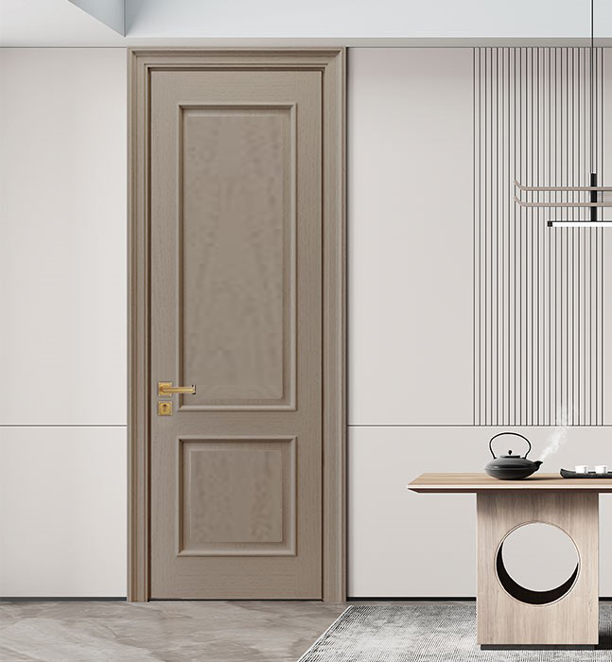 | Product certificate of conformance and quality is required
2 | Skirtboard MDF ГОСТ 32274 - 2021 | 70 x 20 mm, L = 2.8 m | 320 | p c s |  | Product certificate of conformance and quality is required
Note : MDF doors and skirtboards will be supplied at a time. Payment shall be accepted on actual basis only. Installation of MDF doors will be carried out by the supplier company.

For technical questions please contact :
Javid Eminov
Tel: +99450 2740251
E-mail: Cavid.Eminov@asco.az

Due diligence shall be performed in accordance with the Procurement Guidelines of ASCO prior to the conclusion of the purchase agreement with the winner of the bidding.
The company shall enter through this link http: //asco.az/sirket/satinalmalar/podratcilarin-elektron-muraciet-formasi// to complete the special form or submit the following documents:
- Articles of Association of the company (all amendments and changes including)
- An extract from state registry of commercial legal entities (such extract to be issued not later than last 1 month)
- Information on the founder in case if the founder of the company is a legal entity
- Certificate of Tax Payer`s Identification Number
- Audited accounting balance sheet or tax declaration (depending on the taxation system) / reference issued by taxation bodies on non-existence of debts for tax
- Identification card of the legal representative
- Licenses necessary for provision of the relevant services / works (if any)

No agreement of purchase shall be concluded with the company which did not present the above-mentioned documents or failed to be assessed positively as a result of the due diligence performed and shall be excluded from the bidding!

