Approved by the order of the Chairman of "Azerbaijan Caspian Shipping Closed Joint Stock Company dated 1st of December 2016 No. 216.

AZERBAIJAN CASPIAN SHIPPING CLOSED JOINT STOCK COMPANY IS ANNOUNCING OPEN BIDDING FOR THE PROCUREMENT OF GOODS AND MATERIALS REQUIRED FOR THE TECHNICAL MAINTENANCE CHAMBER FOR THE COMMUNICATION AND POWER RADIO NAVIGATION EQUIPMENT OF THE PRODUCTION SERVICES DEPARTMENT UNDER THE AEGIS OF ASCO
B I D D I N G No. AM101/2022

Submission documentation required for participation in the bidding:
- Application for participation in the bidding (template has been attached hereto);
- Bank evidence as a proof of participation fee;
- Bidding offer:
- Bank document confirming financial condition of the consignor within the last year (or within the period of operation if less than one year);
- Statement issued by the relevant tax authorities on the absence of expired commitments associated with taxes and other compulsory payments and failure of obligations set forth in the Tax Code of the Republic of Azerbaijan for the last one year (excluding the period of suspension).

At the initial stage, application for participation in the bidding ( signed and stamped ) and bank evidence proving payment of participation fee (excluding bidding offer) shall be submitted in English, Russian or in Azerbaijani languages to the official address of "Azerbaijan Caspian Shipping" CJSC (hereinafter referred to as "ASCO" or "Procuring Organization") through email address of contact person in charge by 17.00 (Baku time) on 18.04.2023. Whereas, other necessary documents shall be submitted as enclosed in the bidding offer envelope.

Description (list) of goods, works or services has been attached hereto.

The participation fee and Collection of General Terms and Conditions:
- Any participant (bidder), who desires to participate in the bidding, shall pay for participation fee stated below (the payment order shall necessarily state the name of the organization holding open bidding and the subject of the bidding) and shall submit the evidence as a proof of payment to ASCO not later than the date stipulated in section one. All participants (bidders), who have fulfilled these requirements, may obtain General Terms and Conditions relating to the procurement subject from the contact person in charge by the date envisaged in section IV of this announcement at any time from 08.00 till 17.00 in any business day of the week.

- Participation fee amount (VAT exclusive): AZN 50

- The participation fee may be paid in AZN or equivalent amount thereof in USD or EURO.
- Account No. :
AZN | USD | EURO
Name: The International Bank of Azerbaijan  ABB- Customer Service Department  Code: 805250  TAX ID: 9900001881  Correspondent account: AZ03NABZ01350100000000002944  SWIFT: IBAZAZ2X  Beneficiary: AZARB.XAZAR DANIZ GAMICILIYI QSC  TAX ID: 1701579951  Account No. (AZN): AZ36IBAZ38050019441115341120 | Intermediary Bank: Citibank N.Y,  New York  Acc.36083186, SWIFT: CITIUS33  Beneficiary Bank: The International Bank of Azerbaijan  IBA- Customer Service Department  SWIFT: IBAZAZ2X  Nizami str., 67  Beneficiary: AZARB.XAZAR DANIZ GAMICILIYI QSC  TAX ID: 1701579951  Account No.: AZ26IBAZ38150018401115341120 | Intermediary Bank: Commerzbank AG, Frankfurt am Main  SWIFT: COBADEFF  ACC # 400 88 660 3001  Beneficiary Bank: The International Bank of Azerbaijan,  IBA-Premier Customer Service  SWIFT: IBAZAZ2X  Nizami str., 67  Beneficiary: Azerbaijan Caspian Shipping CJSC  TAX ID: 1701579951  Account No.: AZ06IBAZ38150019781115341120

- Except for circumstances where the bidding is cancelled by ASCO, participation fee shall in no case be refunded!

Security for a bidding offer:
- The bank guarantee is required in the amount of at least 1 (one) % of the bidding offer price. A bank guarantee sample shall be specified in the General Terms and Conditions.
- Bank guarantees shall be submitted as enclosed in the bidding offer envelope along with the bidding offer. Otherwise, the Purchasing Organization shall reserve the right to reject such offer.
- The financial institution that issued the guarantee should be acknowledged in the Republic of Azerbaijan and / or international financial transactions. The purchasing organization shall reserve the right not to accept and reject any unreliable bank guarantee.
- Persons wishing to participate in the bidding and intending to submit another type of warranty (letter of credit, securities, transfer of funds to the special banking account set forth by the Procuring Organization in the bidding documents, deposit and other financial assets) shall request and obtain a consent from ASCO through the contact person reflected in the announcement on the acceptability of such type of warranty.
- A contract performance bond is required in the amount of 5 (five) % of the purchase price.
- For the current procurement operation, the Procuring Organization is expected to make payment only after the goods have been delivered to the warehouse, no advance payment has been intended.
Contract Performance Term:
- It is provided that the goods to be delivered within 10 days due to emergence of urgent demand for the goods.

Final deadline date and time for submission of the bidding offer:
- All participants, which have submitted their application for participation in the bidding and bank evidence as a proof of payment of participation fee by the date and time stipulated in section one, and shall submit their bidding offer (one original and two copies) enclosed in sealed envelope to ASCO by 17.00 Baku time on April 26, 2023.

- All bidding offer envelopes submitted after the above-mentioned date and time shall be returned unopened.
Address of the procuring company:
The Azerbaijan Republic, Baku city, AZ1003 (postcode), 2 Mikayil Useynov street, Procurement Committee of ASCO.
Contact person in charge:
Emil Hasanov
Senior procurement specialist at the Procurement Department of ASCO
Telephone No.: +99450 422 00 11
E-mail: emil.hasanov@asco.az, tender@asco.az

Contact person on legal issues:
Landline No.: +994 12 4043700 (ext: 1262)
Email address: tender@asco.az
Date and time assigned for the opening of bidding offer envelopes:
Opening of the envelopes shall take place on April 27, 2023 at 11.00 Baku time in the address stated in section V of the announcement.
Persons wishing to participate in the opening of the envelopes shall submit a document confirming their permission to participate (the relevant power of attorney from the participating legal entity or natural person) and the ID card at least half an hour before the commencement of the bidding.
Information on the winner of the bidding :
Information on the winner of the bidding will be posted in the "Announcements" section of the ASCO official website.

(On the participant`s letter head)
APPLICATION FOR PARTICIPATION IN
THE OPEN BIDDING

___________ city “__”_______20_
___________№

To the attention of the Chairman of ASCO Procurement Committee
Mr Jabrail Mahmudlu

We, hereby confirm the intention of [ to state full name of the participant ] to participate in the open bidding No. [ bidding No. shall be inserted by participant ] announced by ASCO in respect of procurement of "__________________" .
Moreover, we confirm that no winding - up or bankruptcy proceeding is being performed or there is no circumstance of cessation of activities or any other circumstance that may impede participation of [ to state full name of the participant ] in the stated bidding.
In addition, we warrant that [ to state full name of the participant ] is not an affiliate of ASCO.
Below-mentioned contact details are available to respond to any question that may emerge in relation to the documents submitted and other issues:

- Contact person in charge:
- Position of the contact person:
- Telephone No.:
- E-mail:

Attachment:
- Original of the bank evidence as a proof of payment of participation fee – __ page(s).

________________________________ _______________________
(initials of the authorized person) (signature of the authorized person)
_________________________________
(position of the authorized person)

STAMP HERE

LIST OF THE GOODS:
№ | Name of goods, materials and equipment (shall be written in Azerbaijani and English) | Code, type, make, parameters, drawing No. and other information (shall be written accurately and completely) | Quantity | Measurement unit
 | Requisition No. 10059077
1 | LED TV Backlight strip bar for LG 32LB 590 mm 6v 2w 6led Aluminum | 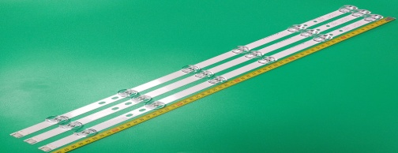  32" DRT3.0 REV0.9 A - TYPE  32" DRT3.0 REV0.9 B - TYPE | 40 | p c s
2 | LED TV backlight strip bar for LG 65LB A:346 mm B:582 mm C: 446 mm  6v 2w 3 led + 5 led + 4 led  Aluminum | 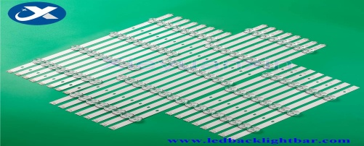  INNOTECK DRT 3.0 65INCH_B TYPE REV1.5_140107  INNOTECK DRT 3.0 65INCH_C TYPE REV1.5_140107  INNOTECK DRT 3.0 65INCH_A TYPE REV1.5_140107 | 40 | p c s
3 | LED TV backlight strip bar for LG 32LN 7LED 630 mm * 12 mm  3v 1w 7 led Aluminum | 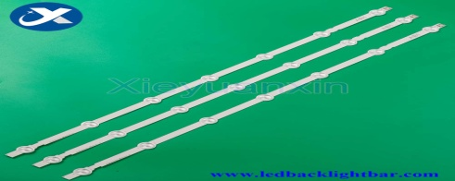  32"HD ROW2.1 REV1.02 A1 - TYPE 6916L - 1295A  32"HD ROW2.1 REV1.02 A2 - TYPE 6916L - 1295A  32"V13 REV0.01 B1 - TYPE 6916L - 1438A | 40 | p c s
4 | LED TV backlight strip bar for LG 32LS3400 650 mm 3v 1v 9 led Aluminum | 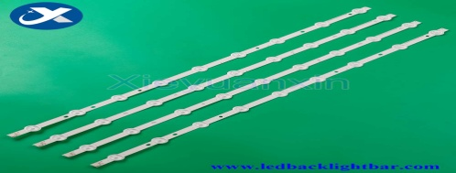  32'' ROW REV0.9 2 A - TYPE 6916L - 0881A  32'' ROW REV0.9 2 B - TYPE 6916L - 0923A | 40 | p c s
5 | LED TV backlight strip bar for LG 42LN R1: 435 mm L1: 404 mm  R2: 425 mm L2: 414 mm  3v 1w 5 led Aluminum | 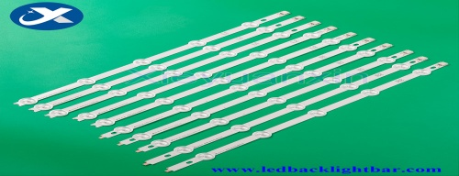  42'' ROW2.0 REV 1.0 L1 - TYPE 6916L - 1120A  42'' ROW2.0 REV 1.0 R1 - TYPE 6916L - 1121A  42'' ROW2.0 REV 1.0 L2 - TYPE 6916L - 1122A  42'' ROW2.0 REV 1.0 R2 - TYPE 6916L - 1123A | 40 | p c s
6 | LED TV backlight strip bar for LG 32LH 5 led 590 mm 3v 1w 5 led aluminum | 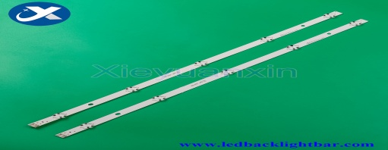  32_inch_HD_REV0.5  LGE_WICOP_SVL_320AL5_150203 | 40 | p c s
7 | LED TV backlight strip bar for Samsung 32D 392 mm 6v 2w 58 led aluminum | 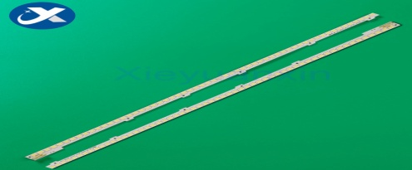  2011SVS32 - FHD - 5K6K - RIGHT JVG4 - 320SMB -R2[10,12,08]  2011SVS32 - FHD - 5K6K - LEFT JVG4 - 320SMA - R2[10,12,08] | 40 | p c s
8 | LED TV backlight strip bar for Toshiba 32 inch 6 led 627 mm 3v 1w 6 led aluminum | 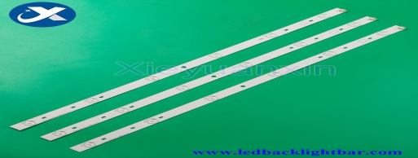  SVT320AF5_P1300_6LED_REV03_130402 | 40 | p c s
9 | LED TV backlight strip bar for Sony 32R 8 led 612 mm 8 led | 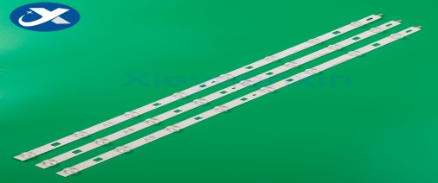  LG INNOTEK 32 INCH NDSOEM A TYPE REV0.1 2013.04.19  LG INNOTEK 32 INCH NDSOEM B TYPE REV0.1 2013.04.19 | 40 | p c s
10 | LED TV Backlight strip bar for Sony 32EX 8 led 3v 619 mm 8 led | 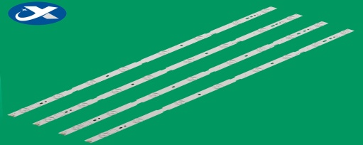  SAMSUNG 2012 SONY 32A 3228 08 REV1.1 SAMSUNG 2012 SONY 32B 3228 08 REV1.1 | 40 | p c s
11 | LED TV backlight strip bar for Sony 32 WC 591 mm 8 led | 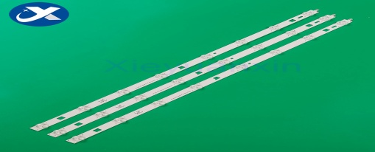  LG Innotek 32 inch WXGA NDSOEM WC TYPE REV0.0 2013.09.27  LG Innotek 32 inch WXGA NDSOEM WD TYPE REV0.0 2013.09.27 | 40 | p c s
12 | LED TV backlight strip bar for Sony 40 inch 5 led 387 mm 5 led | 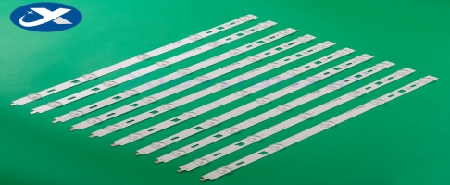  SAMSUNG 2013 SONY 40A 3228 05 REV1.0 130927  SAMSUNG 2013 SONY 40B 3228 05 REV1.0 130927 | 40 | p c s
13 | LED TV backlight strip bar for Sony 65W855C 712 mm 8 led | 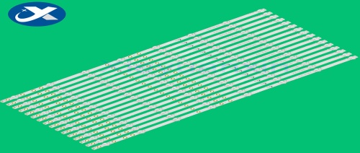  650TV02 V3 CX - 65S03E01 - 2B753 - 0 - C - 5CG - 1350 - V | 40 | p c s
14 | LED TV backlight strip bar for Vestel 32 inch 575 mm 3v 1w 11 led aluminum | 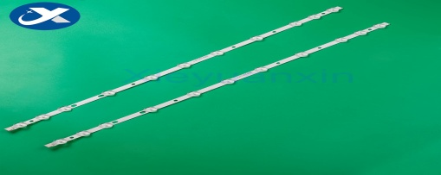  VES315WNDL - 01 VES315WNDS - 01 32D1334DB | 40 | p c s
15 | LED TV backlight strip bar for Hisense 40K30JD 5 LED 400 mm 5 led | 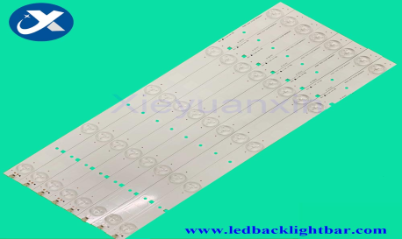  2013CHI400 3228N1 05 REV1.1 REV1.0 141223  SVH390A06 - 5 LED | 40 | p c s
16 | LED TV backlight strip bar for Hisense 42K220JD 5 LED 420 mm 5 led | 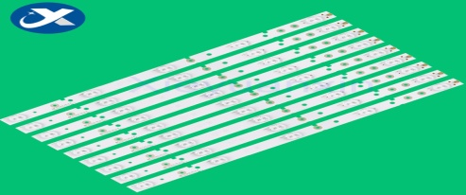  SVH420A72 - REV3 - 5LED - 130114 | 40 | p c s
17 | LED TV backlight strip bar for Hisense 65 inch 6LED 558 mm 6 led | SVH650A53 REV01 6LED UBH 160627 | 40 | p c s
18 | LED TV backlight strip bar for Philips 32 inch 9LED 623 mm 9 led | 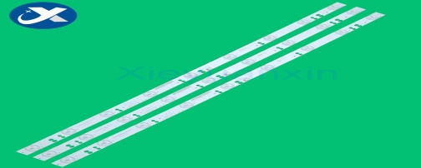  GC32D09 - 2ZC14F - 05 | 40 | p c s
19 | LED TV backlight strip bar for Philips / AOC 32 inch (5 LED) 614 mm 5 led | 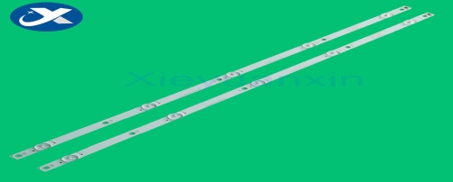  02D320205003 - X1  SKYW0RTH.LCD | 40 | p c s
20 | LED TV backlight strip bar for Philips 32 inch (2 * 7 LED + 1 * 8 LED) 631 mm 2 * 7 led + 1 * 8 led | 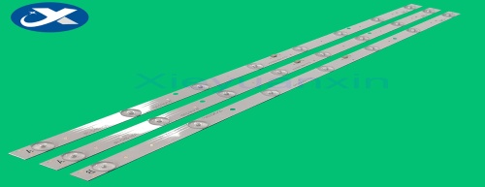  GC315D08 - ZC14F - 02  GC315D07 - ZC14F - 02 | 40 | p c s
21 | LED TV backlight strip bar for Philips 32 inch (7 LED) 614 mm 7 led | 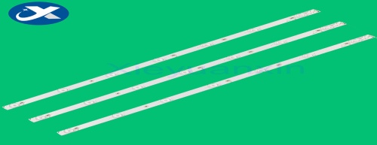  GJ - 2K15 D2P5 - 315 D307 - V3.1 - 01 L68 - 2 | 40 | p c s
22 | LED TV backlight strip bar for Philips 42 inch 9 LED 828 mm 9 led | 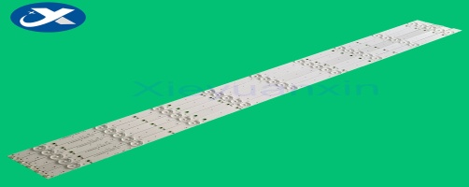  LB - F3528 - GJ420X509 - H | 40 | p c s
23 | LED TV backlight strip bar for Philips 42 / 43 inch (5 LED) 416 mm 5 led | 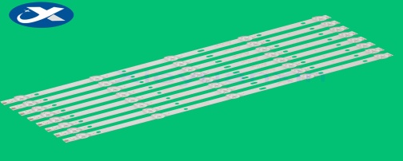  4708 - K420WD - A3213K11 | 40 | p c s
24 | LED TV backlight strip bar for TCL 40 inch 8 led 690 mm 8 led | 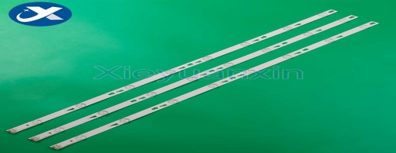  4C - LB4008 - HR3 40HR330M08A3 V2 | 40 | p c s
25 | LED TV backlight strip bar for OC 42 inch 9 LED 828 mm 9 led | 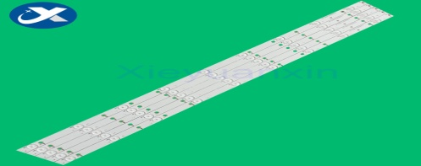  LB - F3528 - GJ420X509 - H | 40 | p c s
26 | LED TV backlight strip bar for TCL 32 inch 7 led 550 mm 7 led | 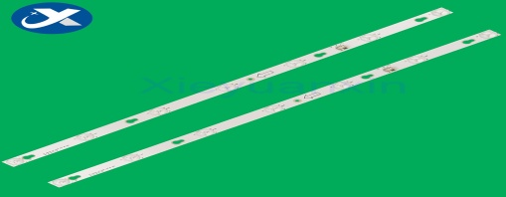  TOT - 32D2700 - 2X7 - 3030C - 7S1P BI - LENS | 40 | p c s
27 | LED TV backlight strip bar for Changhong 65 inch 8 LED 700 mm 8 led | 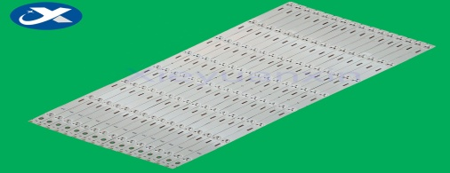  SVJ650A21 - Rev03 - 8 LED - 150106  LB - M650 - E1 - A - SE | 40 | p c s
28 | LED TV backlight strip bar for TCL 32 inch 6 LED Square lens 510 mm 6 led | 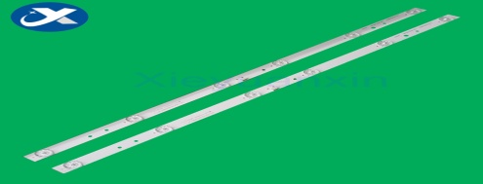  CC02320D510V11 | 40 | p c s
29 | LED TV backlight strip bar for 32 inch 6 led 567 mm 6 led | 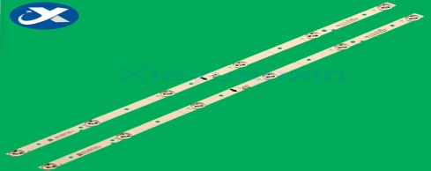  JL.D32061330 - 001SS - M | 40 | p c s
30 | LED TV backlight strip bar for TCL 40 inch 8 led 780 mm 8 led | 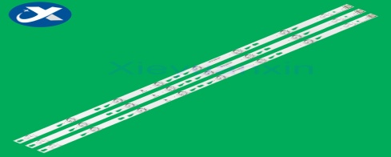  TOT _ 40F3800 _ 3 x 8 _ 3030C _ V1 | 40 | p c s
31 | LED TV backlight strip bar for Skyworth 32 inch 6 LED 549 mm 6 led | 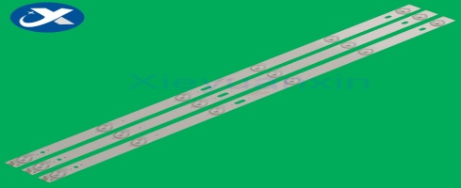  MX32D06 - ZC21FG - 05 303MX320031 MX315M09 | 40 | p c s
32 | LED TV backlight strip bar for Asamzo 32 inch 5 LED 553 mm 5 led | 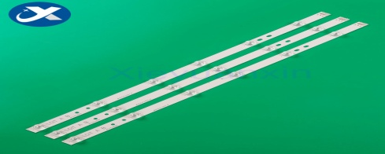  JS - D - JP32EU - 051EC | 40 | p c s
33 | LED TV universal backlight strip bar for 32 inch 6 LED 3v 590 mm 6 led | 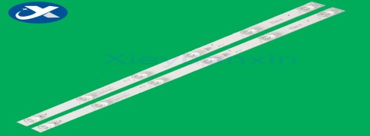  4CT - LB320T - JF5 GY6 JF3 JF4 | 40 | p c s
34 | LED TV backlight strip bar for TCL 32 inch 7 LED 600 mm 7 led | 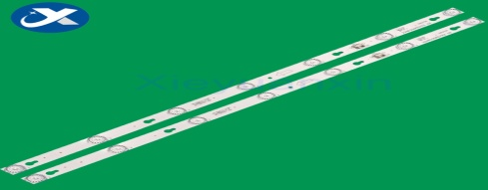  32HR330M07A2 V2 | 40 | p c s
35 | LED TV backlight strip bar for SAMSUNG 32F 9 LED 650 mm 9 led | 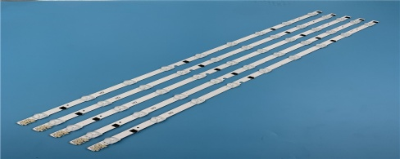  2013SVS32H / F D2GE - 320SC0 - R3 | 40 | p c s
36 | LED TV backlight strip bar for TCL 32 inch 6 LED 580 mm 6 led | 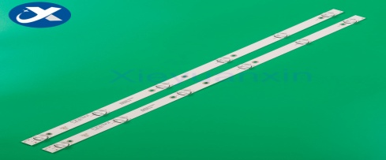  JL.D32061330 - 081AS - M L2202 | 40 | p c s
37 | LED TV backlight strip bar for KONKA 32 inch 10 LED 644 mm 10 led | 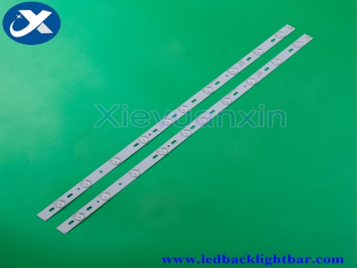  35017727 | 40 | p c s
38 | LED TV backlight strip bar for TCL / AOC / PHILIPS 49 inch 6 LED 498 mm 6 led | 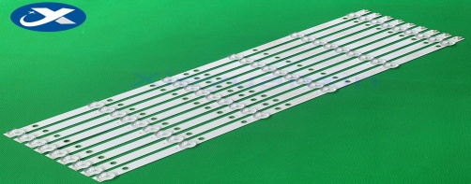  4708 - K490WD - A2213K01 K490WD7 A2 | 40 | p c s
39 | LED TV backlight strip bar for TCL 49 inch 7 LED 610 mm | 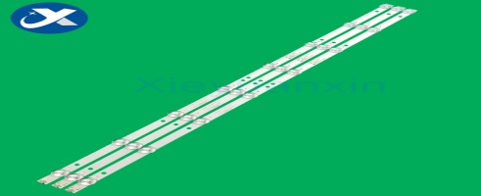 | 40 | p c s
40 | LED TV backlight strip bar for Hair 32 inch 10 LED 635 mm 10 led | 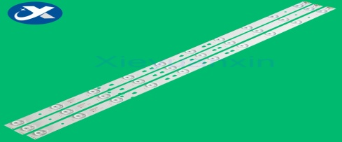  LED315D10 ZC14 07 30331510 | 40 | p c s
41 | LED TV backlight strip bar for Millet 43 inch 7 LED 799 mm 7 led | 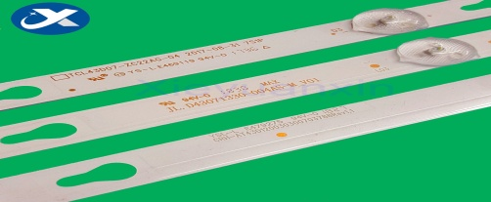  CRH - AT43D120030300703788REV1.1G | 40 | p c s
42 | LED TV backlight strip bar for Haier 43 inch 10 led  square lens A: 854 mm 10 led  B: 854 mm 10 led | 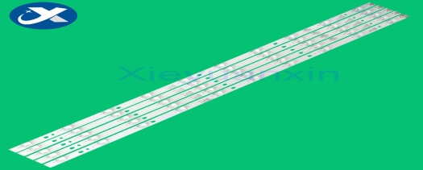  LED43D10A - ZC14FG - 01 | 40 | p c s
43 | LED TV backlight strip bar for 42 inch 12led DH42D12 - ZC14F - 01 825 mm 12 led | 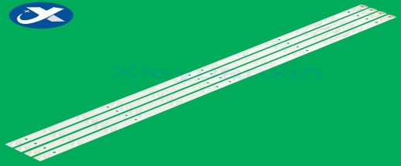  DH42D12 - ZC14F - 01 | 40 | p c s
44 | LED TV backlight strip bar for ATA 40 inch 8 LED + 8 LED 736 mm 8 led | 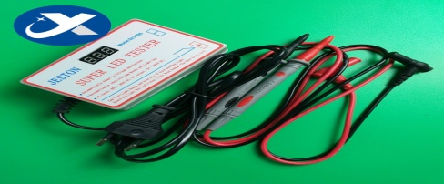  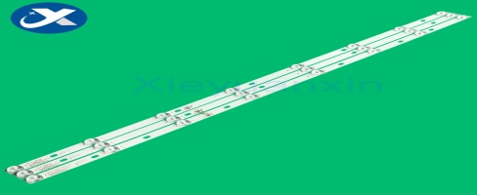  JS - D - JP395DM - A81EC  JS - D - JP395DM - B81EC | 40 | p c s
45 | LED TV backlight strip bar for LG 43 LF 471 mm 36 led | 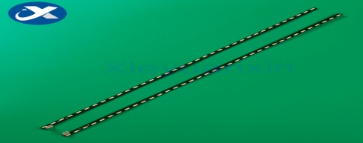  LGlnnotek BMS 43 inch L / R - Type 8520  1 chip PKG 72EA REV.00 141022 | 40 | p c s
46 | LED TV backlight strip bar for LG 42LS 60 LED 531 mm 60 led | 6920L - 0001C 6922L - 0016A | 40 | p c s
47 | LED TV backlight strip bar for PH42F10 42 inch 9 LED 810 mm 9 led | 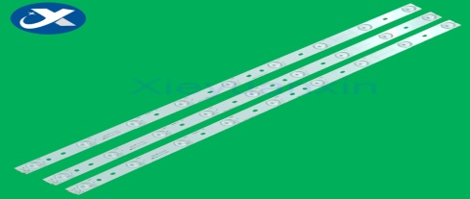  JL.D42091330 - 002BS - M | 40 | p c s
48 | LED TV backlight strip bar for Philips 32 inch 6 led square lens 570 mm 6 led | 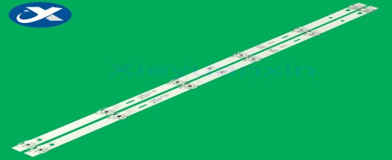  4708 - K320WD - A3113N11 | 40 | p c s
49 | LED TV backlight strip bar for Skyworth 32 inch 7 led 564 mm 7 led | 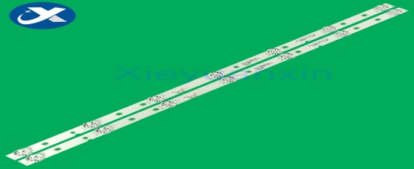  JL, D32071330 - 001CS - M | 40 | p c s
50 | LED TV backlight strip bar for LG 32CSP 8 led 590 mm 3v 1w 8 led Aluminum | 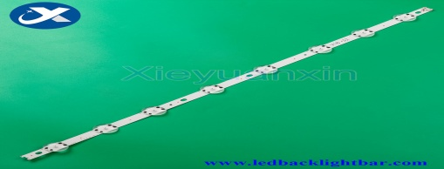  32'' V17 ART 2855 REV0.1  32'' V18 DRT 3148 Rev0.1 2 | 40 | p c s
51 | LED TV backlight strip bar for 32 inch 10 LED 633 mm 10 led | 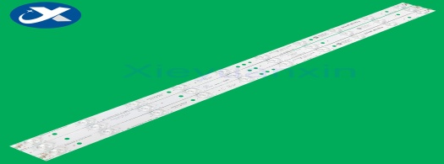  4708 - K320WD - A4211V01  3BL - T6324102 - 001B/2B  HK32D10P - ZC14A - 01  HK32D10M -ZC14A - 01 | 40 | p c s
52 | LED TV backlight strip bar for Sharp 32 inch 5 LED 610 mm 5 led | 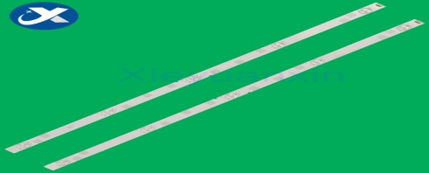  LBM320E0501 - JJ - 3 | 40 | p c s
53 | LED TV backlight strip bar for Samsung 40J 4 + 3 led 774 mm 3v 1w 8 led Aluminum | 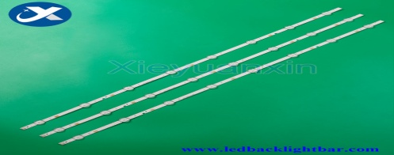  V5DN - 395SM0 - R3  39.5'' FHD 180212 - JEDI 2 - 6.2/2.3 | 40 | p c s
54 | LED TV backlight strip bar for TCL 32 inch 6 LED 580 mm 6 led | 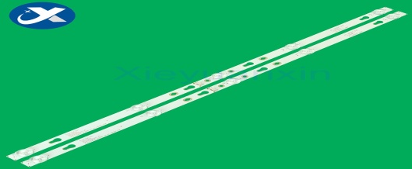  32HR332M05A7 4C - LB320T - HRB | 40 | p c s
55 | LED TV backlight strip bar for LG 42V 5 + 4 led 615 mm 5 + 4 led | 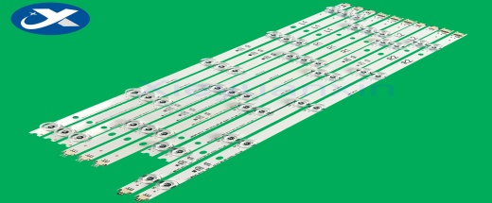  42'' V14 Slim DRT Rev0.6 6916L - 1682A | 40 | p c s
56 | LED TV backlight strip bar for LG 42 inch 5 + 5 led 412 mm 5 + 5 led | 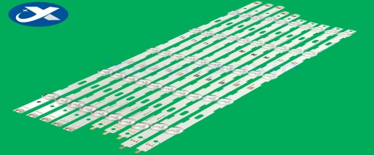  6916L - 1402A / 1403A / 1404A / 1405A | 40 | p c s
57 | LED TV backlight strip bar for LG 43 inch 5 + 4 led L : 500 mm 5 led  R : 450 mm 4 led | 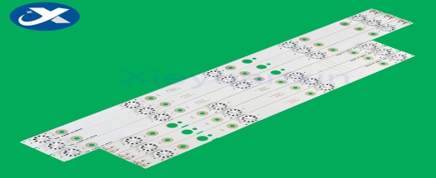  A4330300104L74CREV1.0  CRH - A4330300105R74CREV1.0 | 40 | p c s
58 | LED TV backlight strip bar for Haier 42 inch 10 ld square lens 822 mm 10 led | 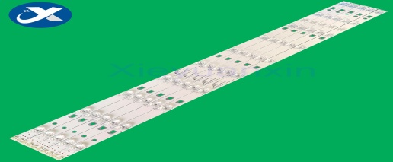  LED42D10B - ZC14DFG - 01 | 40 | p c s
59 | LED TV backlight strip bar for Skyworth 40 inch 7 led 749 mm 7 led | 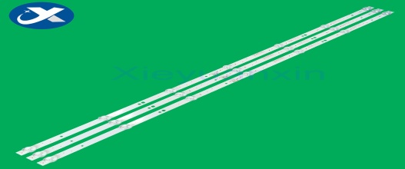  5850 - W40000 - 9P00 | 40 | p c s
60 | LED TV backlight strip bar for Toshiba 32 inch 8 led 627 mm 3v 1w 8 led aluminum | 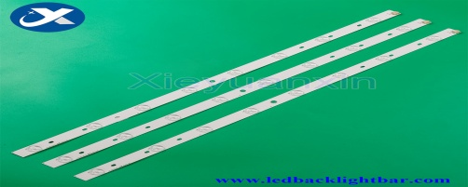  SVT320AE9 _ REV 1.0 _ 121012 | 40 | p c s
61 | LED TV universal backlight strip bar for 32 inch 6 led 3V 650 mm 6 led | 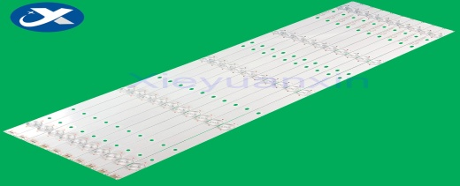 | 40 | p c s
62 | LED TV backlight strip bar for Haier 40 inch 11 led 800 mm 11 led | 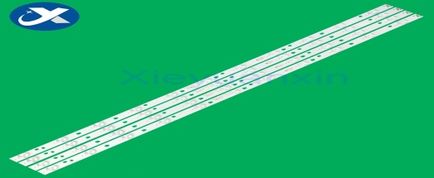  LED40D11 - ZC14 - 03(B) | 40 | p c s
63 | LED TV backlight strip bar for Philips 42 inch 5 led 417 mm 5 led | 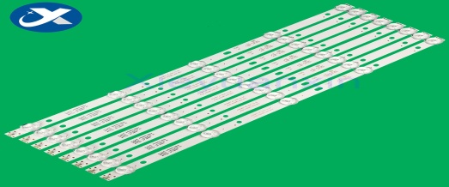  4708 - K420WD - A3213K01 | 40 | p c s
64 | LED TV backlight strip bar for Samsung 65 inch 8 + 6 led L : 757 mm 8 led  R : 587mm 6 led | 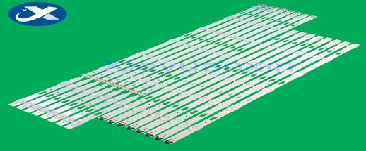  S_5U75_65_FL_L8_REV1.4_150514_LM41-00121F  S_5U75_65_FL_R6_REV1.4_150514_LM41-00121E | 40 | p c s
65 | LED TV backlight strip bar for Samsung 40D 440 mm 6v 2w 62 led aluminum | 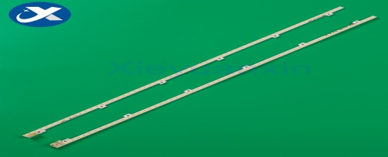  2011SVS40 - FHD - 5K6K - RIGHT  2011SVS40 - FHD - 5K6K - LEFT | 40 | p c s
66 | LED TV backlight strip bar for Vestel 48 inch 5 LED + 5LED 459 mm 5 led | 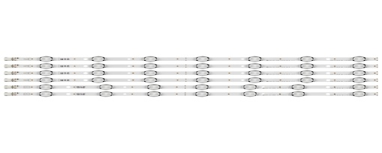  VESTEL 48" UHD DRT VNB A - Type  VESTEL 48" UHD DRT VNB B - Type | 40 | p c s
67 | LED TV backlight strip bar for TCL 42 inch 9 led 830 mm 9 led | 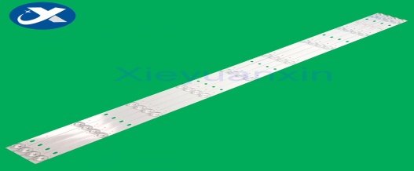  CRH - E423535T040941J - REV1.0 | 40 | p c s
68 | LED TV backlight strip bar for 32 inch 8 led 576 mm 6 led | 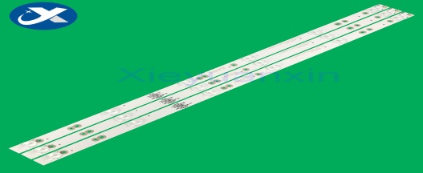  0D32D06 - ZC21FG - 05 303TT320038 | 40 | p c s
69 | LED TV backlight strip bar for LG 42 inch 6 + 6 L : 430 mm 6 led  R : 445 mm 6 led | 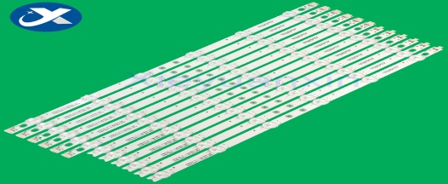  6916L - 1028 A  6916 L - 1029A | 40 | p c s
70 | LED TV backlight strip bar for Hisense 32 inch 6 led 579 mm 6 led | 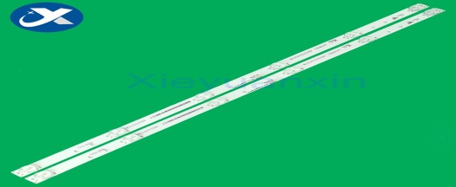  Hisense _ 32 _ 32PL4 _ 3030C | 40 | p c s
71 | LED TV backlight strip bar for Hisense 40 inch 54 led 500 mm 54 led | SSY _ 1125050 RSAG7.820.5057 HE400GF - B31 | 40 | p c s
72 | LED TV backlight strip bar for LG 32 inch 7 led 639 mm 7 led | 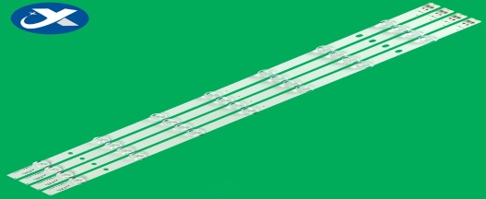  LG Innotek 32''NDE RE | 40 | p c s
73 | LED TV backlight strip bar for TCL 32 inch 6 led 560 mm 6 led | 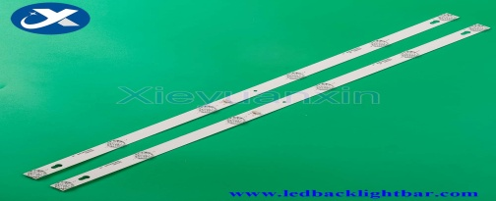  4C - LB3206 - HR01J 32HR330M06A5 /32HR330M06A8 32D2900 | 40 | p c s
74 | LED TV backlight strip bar for KONKA 32 inch 10 LED 644 mm 10 led | 35017727 | 40 | p c s
75 | LED TV backlight strip bar for KONKA LED48M2600B 5 LED + 6 LED L : 507 mm  R : 510 mm | 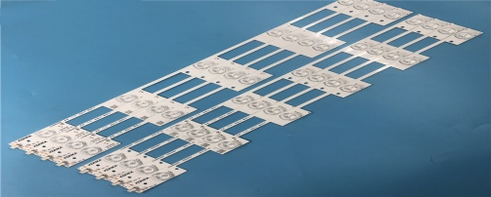  LED48M2600B 35020492 35020493 | 40 | p c s

Payment condition will be accepted "on actual basis" only. Different kind of payment condition proposal offering advance payment will be excluded. Certificate of origin and conformity for the supplied goods is required.
Only DDP shall be accepted as a delivery term form local entities. Price offers shall be accepted in manats. Other conditions shall not be accepted.

For technical questions please contact :
Emil Hasanaov - Senior specialist at the Procurement Department of ASCO

T:+994 504220011
E-mail: : emil.hasanov@asco.az

Due diligence shall be performed in accordance with the Procurement Guidelines of ASCO prior to the conclusion of the purchase agreement with the winner of the bidding.
The company shall enter through this link http: //asco.az/sirket/satinalmalar/podratcilarin-elektron-muraciet-formasi// to complete the special form or submit the following documents:
- Articles of Association of the company (all amendments and changes including)
- An extract from state registry of commercial legal entities (such extract to be issued not later than last 1 month)
- Information on the founder in case if the founder of the company is a legal entity
- Certificate of Tax Payer`s Identification Number
- Audited accounting balance sheet or tax declaration (depending on the taxation system) / reference issued by taxation bodies on non-existence of debts for tax
- Identification card of the legal representative
- Licenses necessary for provision of the relevant services / works (if any)

No agreement of purchase shall be concluded with the company which did not present the above-mentioned documents or failed to be assessed positively as a result of the due diligence performed and shall be excluded from the bidding!

